Data Structure and Algorithm

Laboratory Activity No. 4

Arrays

|  |  |
| --- | --- |
| *Submitted by:* | *Instructor:* |
| Monoy, Justin Rhey A. | Engr. Maria Rizette H. Sayo |

August, 09, 2025

# Objectives

Introduction

Array, in general, refers to an orderly arrangement of data elements. Array is a type of data structure that stores data elements in adjacent locations. Array is considered as linear data structure that stores elements of same data types. Hence, it is also called as a linear homogenous data structure.

This laboratory activity aims to implement the principles and techniques in:

* Writing algorithms using Array data structure
* Solve programming problems using dynamic memory allocation, arrays and pointers

# Methods

Jenna’s Grocery

Jenna wants to buy the following fruits and vegetables for her daily consumption. However, she needs to distinguish between fruit and vegetable, as well as calculate the sum of prices that she has to pay in total.

Problem 1: Create a class for the fruit and the vegetable classes. Each class must have a constructor, deconstructor, copy constructor and copy assignment operator. They must also have all relevant attributes (such as name, price and quantity) and functions (such as calculate sum) as presented in the problem description above.

Problem 2: Create an array GroceryList in the driver code that will contain all items in Jenna’s Grocery List. You must then access each saved instance and display all details about the items.

Problem 3: Create a function TotalSum that will calculate the sum of all objects listed in Jenna’s Grocery List.

Problem 4: Delete the Lettuce from Jenna’s GroceryList list and de-allocate the memory assigned.

# Results

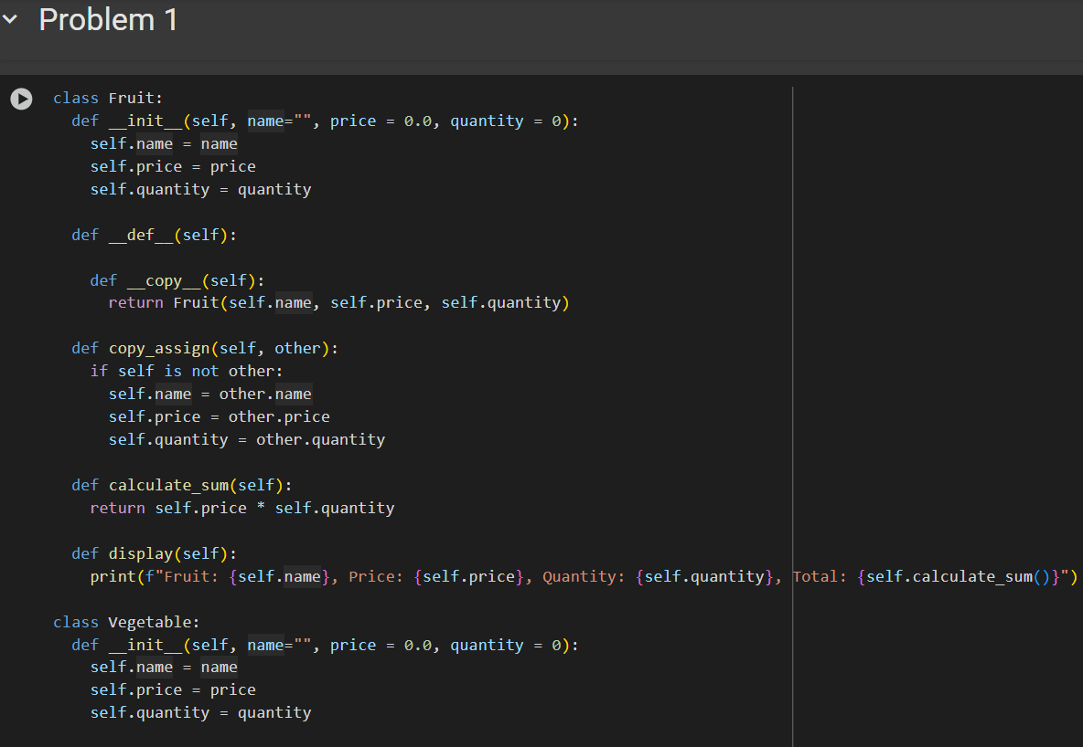

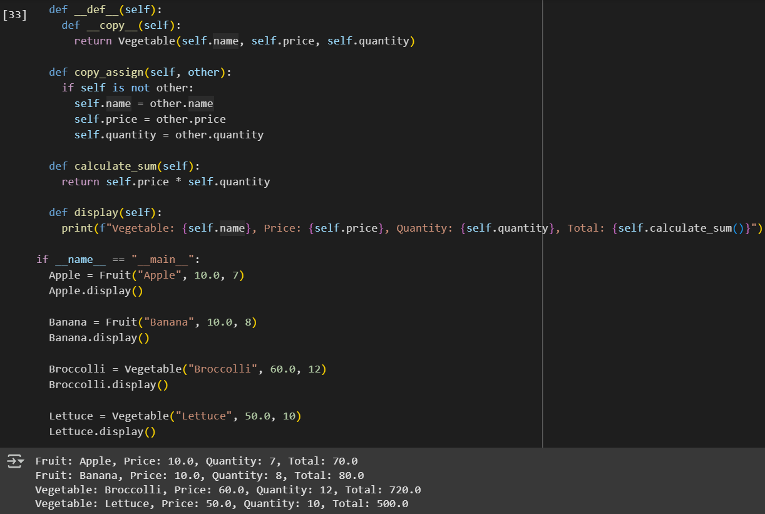

Figure 1. Problem 1

In this program, the code shows how to make classes for fruits and vegetables. It uses a constructor to set the first values when an object is made, a destructor to run when an object is deleted, a copy constructor to make a new object with the same values as another, and a copy assignment operator to copy values from one object to another. The copy_assign function checks if the object is not the same as the other before copying the name, price, and quantity. The calculate_sum function multiplies the price by the quantity to find the total cost.

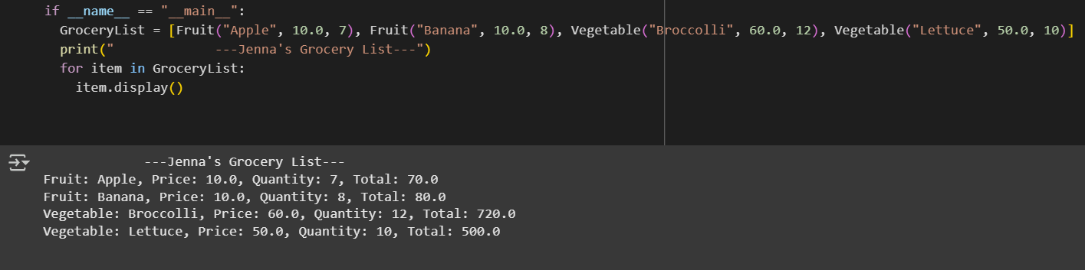

Figure 2. Problem 2

This program is a continuation of Problem 1. It uses an array to store Jenna’s grocery list. Each place in the array holds one item, and each item has its own class type, name, price, and quantity. The program goes through the array one by one and shows all the details of each item.

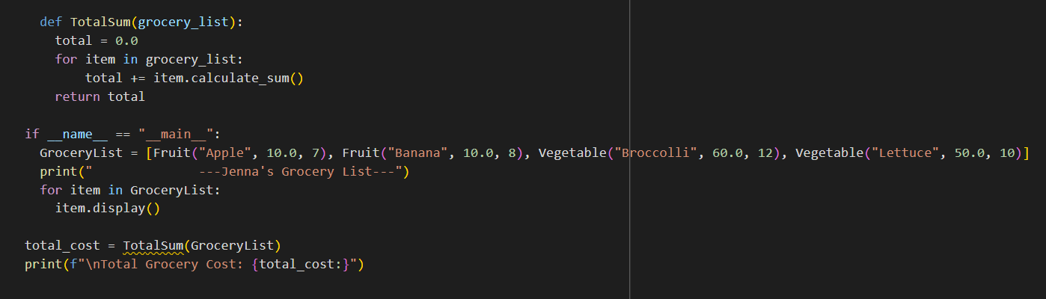

Figure 3. Problem 3

This program is a continuation of Problems 1 and 2. It adds a TotalSum function to find the total cost of Jenna’s grocery list. The function checks each item in the list, multiplies its price by its quantity, and adds all the results together. The final amount is stored in the variable total_cost by calling TotalSum(GroceryList), and then the program shows the total cost.

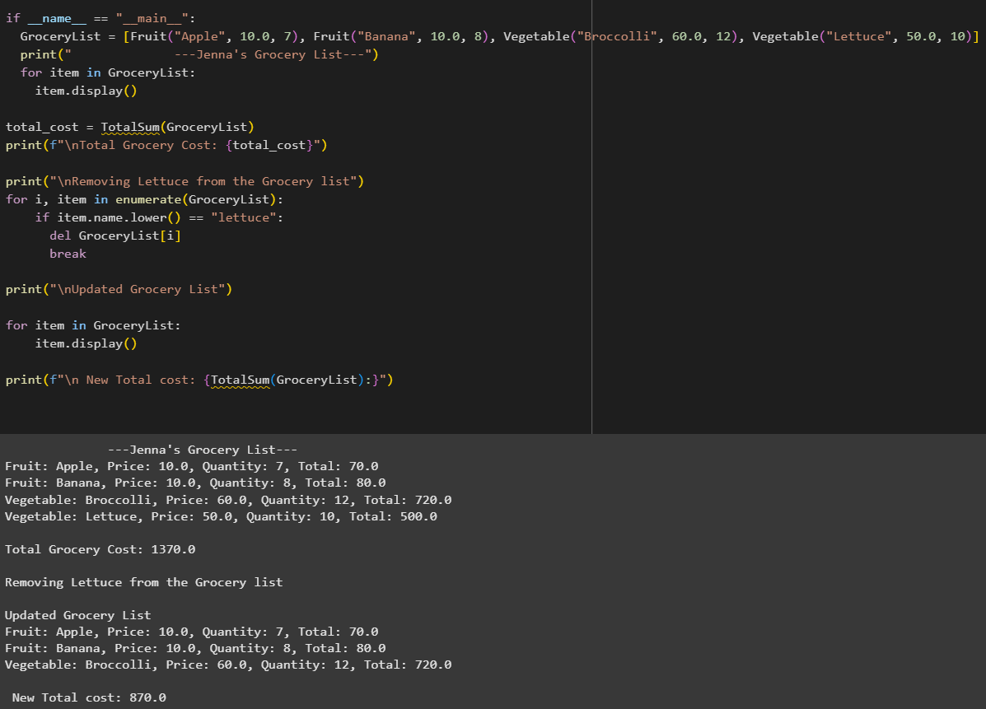

Figure 4. Problem 4

This program is a continuation of Problems 1, 2, and 3. It removes the item “Lettuce” from Jenna’s grocery list and frees the memory used by that item. The program searches the list to find “Lettuce,” deletes it, and updates the list so the removed item no longer appears. The total cost also changes from 1370 to 870 because the vegetable “Lettuce” is no longer included. This keeps the grocery list clean and only shows the items that are still needed.

# Conclusion

In this activity, I learned how to use a constructor, destructor, copy constructor, and copy assignment operator in a program. The constructor is useful for setting the first values when an object is created, while the destructor helps clean up when the object is no longer needed. The copy constructor makes a new object with the same values as another, and the copy assignment operator allows one object to take the values of another without creating a new one. By using these, I understood how to manage and work with object data better, making the program more organized and easier to control.

**References**

[1] GeeksforGeeks, “Constructors in Python,” *GeeksforGeeks*, Jul. 11, 2025.

<https://www.geeksforgeeks.org/python/constructors-in-python/>

[2]S. Somani, “Destructor in Python - Scaler topics,” *Scaler Topics*, Oct. 11, 2022. <https://www.scaler.com/topics/destructor-in-python/>

[3] A. Trivedi, “Constructors in Python: Definition, types, and rules,” *Analytics Vidhya*, May 26, 2025. <https://www.analyticsvidhya.com/blog/2024/01/constructors-in-python/>

[4] GeeksforGeeks, “Assignment operators in Python,” *GeeksforGeeks*, Jul. 15, 2025. <https://www.geeksforgeeks.org/python/assignment-operators-in-python/>